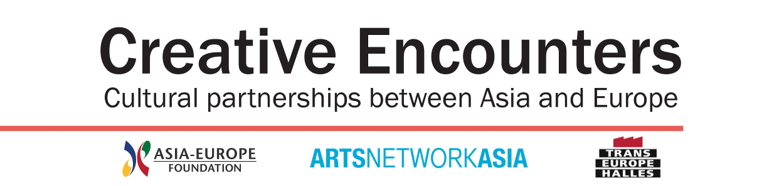

APPLICATION FORM

- This application has to be submitted in English through ANA website (www.artsnetworkasia.org) by 31 July 2012.
- Please save the completed form in PDF format and the file size is not larger than 1 MB.
- Please pay careful attention to completing this application form and do not attach any files.
- Project proposed jointly by a minimum of 2 partners in Asia and Europe, one partner from each region.

PARTNER 1

Name

Address
City
Postal Code
Country

Website URL

Please select Arts Discipline
- Hybrid Interdisciplinary
- Visual Arts
- Film/Video/New Media
- Performing Arts
- Literature
- Critical Discourse
- Arts Management
- Technical Arts
- Others (Please specify)

Head of organisation

Name
Designation

CONTACT person

Name
Designation
Email

Complete phone number including Country Code and Area Code, e.g. +62-21-12345678

Mobile No.
Office No.
Home No.
Fax No.

Bio/PROFILE of partner 1

Please fill in maximum 200 words.

PARTNER 2
Name

Address
City
Postal Code
Country

Website URL

Please select Arts Discipline
- Hybrid Interdisciplinary
- Visual Arts
- Film/Video/New Media
- Performing Arts
- Literature
- Critical Discourse
- Arts Management
- Technical Arts
- Others (Please specify)

Head of organisation

Name
Designation

CONTACT person

Name
Designation
Email

Complete phone number including Country Code and Area Code, e.g. +62-21-12345678

Mobile No.
Office No.
Home No.
Fax No.

BIO/PROFILE of partner 2
Please fill in maximum 200 words.

OTHER PARTNER (IF APPLICABLE)

Name

Address
City
Postal Code
Country

Website URL

Please select Arts Discipline
- Hybrid Interdisciplinary
- Visual Arts
- Film/Video/New Media
- Performing Arts
- Literature
- Critical Discourse
- Arts Management
- Technical Arts
- Others (Please specify)

Head of organisation

Name
Designation

CONTACT person

Name
Designation
Email

Complete phone number including Country Code and Area Code, e.g. +62-21-12345678

Mobile No.
Office No.
Home No.
Fax No.

Bio/PROFILE of other partner
Please fill in maximum 200 words.

PROJECT PROPOSAL

Project Title

BRIEF DESCRIPTION OF THE PROJECT (CONCEPT)
Please fill in maximum 200 words.

ASIA-EUROPE PERSPECTIVES WITHIN THE PROPOSED PROJECT
Please fill in maximum 200 words.

OBJECTIVES
Please state 2 main objectives of the initiative, each maximum 100 words.

Objective 1:

Objective 2:

timeframe

Duration of entire initiative
Possible dates of the public events
From MM/YY To MM/YY

PROJECTED OUTPUTS
Please list specific outputs of the project such as number of public performance, websites and publication.

OUTPUT 1
OUTPUT 2

TOTAL PROJECT BUDGET (SGD)

EXPECTED FINANCIAL CONTRIBUTION FROM THE CREATIVE ENCOUNTERS PRoGRAMME (SGD)
Please note that the support will be around 50% of the total project cost with maximum cap of SGD 25,000 for each project.

